**Expense Wise Documentation**

# **Introduction**

# Purpose

Expense Wise aims to address the need for users to efficiently track their expenses, manage expense categories, set budgets, and work towards their savings goals. This project aims to provide users with an intuitive and user-friendly desktop application to help them gain better control over their finances whilst maintaining privacy.

# Problem Statement

Managing personal finances can be challenging, and people often struggle to keep track of their expenses and savings. This project aims to address this problem by providing a centralized and easy-to-use expense tracking solution that empowers users to make informed financial decisions. The more users it is able to help the more beneficial it is for the stakeholders and company financial wise. The beauty of this application is that it can be used by any industry as all industries have expenses and need a way to track them.

# Industry/Domain

The industry/domain of the project is financial management and personal finance. This project aligns with the broader financial technology (FinTech) industry, which is witnessing rapid growth due to increased digitalization and demand for innovative financial services.

# Stakeholders

1. Individual Users: Individuals who want to manage their expenses and savings effectively.
2. Financial Institutions: Companies like cashback or accounting firms who want to track expenses effectively
3. Companies: companies with expenses and want to track. Providing them a easy to use, compatible application and a cost effect option

Why reason why stake holders should be care and see this as a opportunity is due to its limitless potential and its growing demand to get on top of your finances. Now more than ever the saying ”every dollar counts” could not be any more relevant. This application servers the purpose of provide a complete end-to-end solution with the ease and connivence of a simple application.

# Product Description

# Architecture Diagram

<https://www.figma.com/file/Jao7LFs6EHvYBwbnAZbwnz/Untitled?type=whiteboard&node-id=0%3A1&t=Bp1IFAPnfFBuEhd2-1>

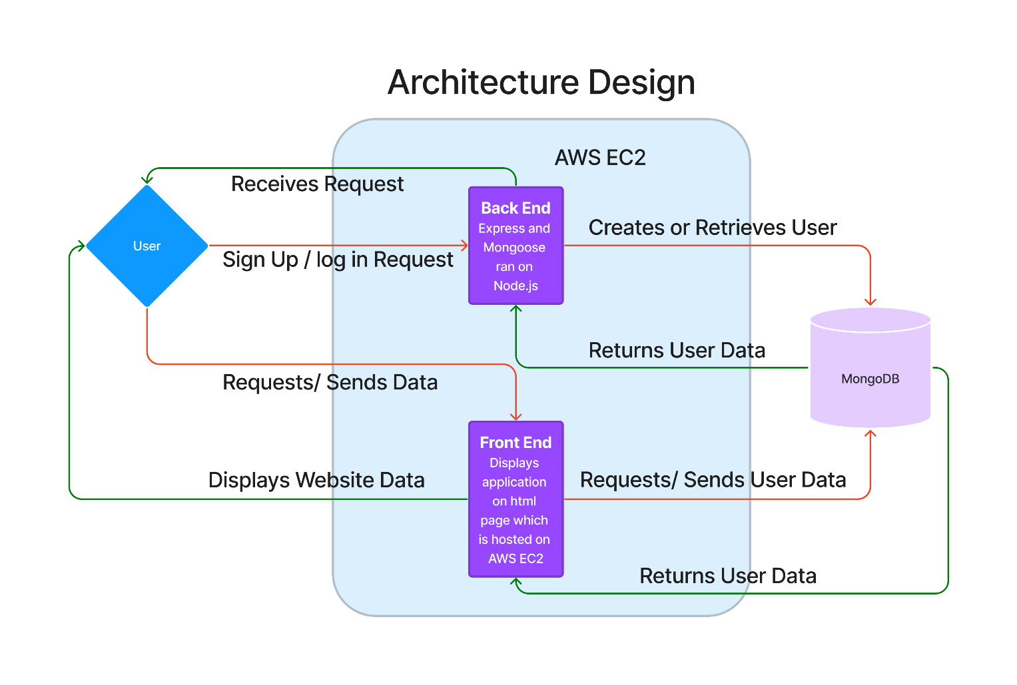

**User Stories**

|  |  |  |
| --- | --- | --- |
| User Story Title | User Story Description | Priority |
| Expense Tracking | As a user, I want to log my daily expenses with categories so that I can keep a record of my spending habits. | High |
| Budget Management | As a user, I want to set budgets for different expense categories to stay within my financial limits. | High |
| Savings Goals | As a user, I want to create and manage savings goals to plan for future expenses and financial milestones. | Medium |
| User Authentication | As a user, I want to create, edit, and delete custom categories for better expense organization. | High |
| Data Encryption | As a user, I want sensitive information like financial data to be encrypted to prevent unauthorized access. | High |
| User Friendly and Comprehensive UI | As a user, I want something that is easy to navigate through, easy to use and most importantly easy to view | High |

**User Flow**

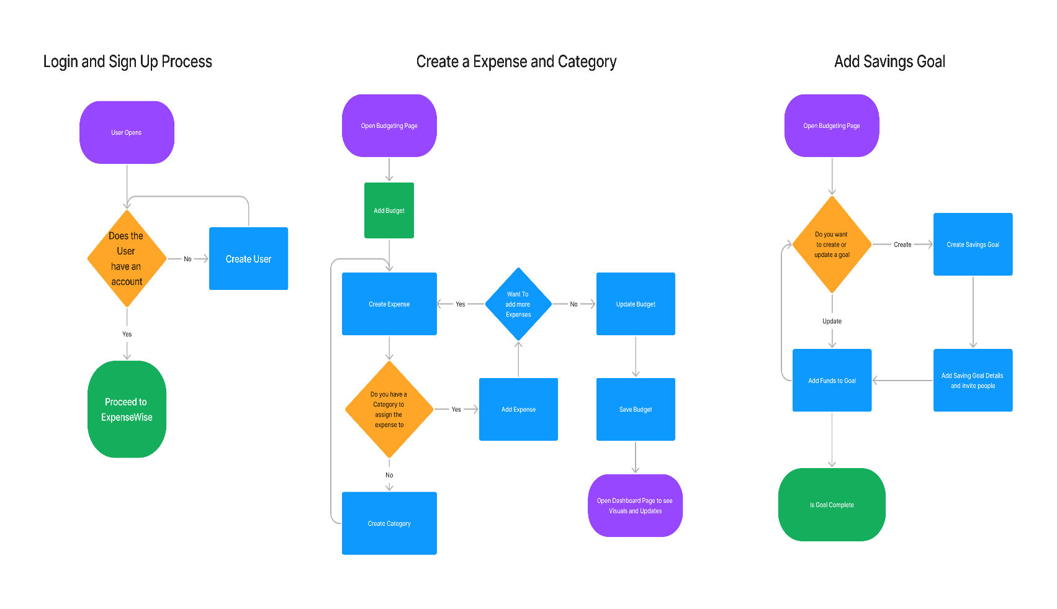<https://www.figma.com/file/reCZAguepbI3wW9g7SnPCL/Untitled?type=whiteboard&t=Bp1IFAPnfFBuEhd21>

**Wireframe Design**

<https://www.figma.com/file/Y7FjbCNOSPkz8JXz6ctjQP/Capstone-Project?type=design&node-id=4%3A10&mode=design&t=Bp1IFAPnfFBuEhd2-1>

**Open Questions/Out of Scope**

* Mobile Optimization
* Collaboration
* Customization
* Linking to banking details
* Hosting on online server and online database
* Data encryption and security

**Non-functional Requirements**

* Login / Signup: Storing user logins and data based off that accounts activity
* Traffic: During peak times this application ideally should run 500 transactions per minute instance
* Software Ease: Needs to be almost baby proof to allow for non tech savvy people to find success when using the application
* Response Time/ reliability: Should be as quick as possible without ruining the integrity of the database and security. Also should maintain 100% uptime as this service could be needed at any time
* Technical Standards: Backend and Front end maintain a MVC structure with commented and organized code.

**Project Planning**

<https://github.com/Neil-Kripal/Capstone-Project/issues>  
<https://github.com/Neil-Kripal/Capstone-Project/milestones>

**Testing Strategy**

* Test cases will be designed and executed to verify the functionality of each feature.
* Unit testing, integration testing, and end-to-end testing will be performed to ensure product quality.
* Edge cases and boundary conditions will be tested to validate the application's robustness.

**Implementation**

**Deployment Considerations**

The software will be deployed as a desktop application compatible with major operating systems (Windows, macOS, Linux).

**End-to-End Solution**

The Expense Tracker application aims to provide a seamless end-to-end solution for users to manage their expenses and savings effectively. User feedback and data analytics will be collected to further enhance the application's usability and functionality.

**References**

* GitHub – Expense Wise Capstone Project: <https://github.com/Neil-Kripal/Capstone-Project>
* Node.js: <https://nodejs.org/>
* Bootstrap: <https://getbootstrap.com/>
* MongoDB: <https://www.mongodb.com/>